**Traffic Light Controller using Microcontroller**

**Name: Siddhartha Maity**

**Year: 3rd**

**Course: B.Tech in Electronics and Communication Engineering**

**Institution: St. Thomas’ College of Engineering and Technology**

**Traffic light control systems** are widely used to monitor and **control** the flow of automobiles through the junction of many roads. They aim to realize smooth motion of cars in the transportation routes.

**Components needed:**

* 8052 Microcontroller.
* Red, Yellow, green Probes.

5V DC supplyThe main objective of this traffic light controller is to provide sophisticated control and coordination to confirm that traffic moves as smoothly and safely as possible. This project makes use of[LED lights](http://www.edgefx.in/requirements-for-solar-led-street-light-system-and-its-applications/) for indication purpose and a microcontroller is used for auto changing of signal at specified range of time interval. LED lights gets automatically turns on and off by making corresponding port pin of the microcontroller “HIGH”.

**Circuit Diagram:**

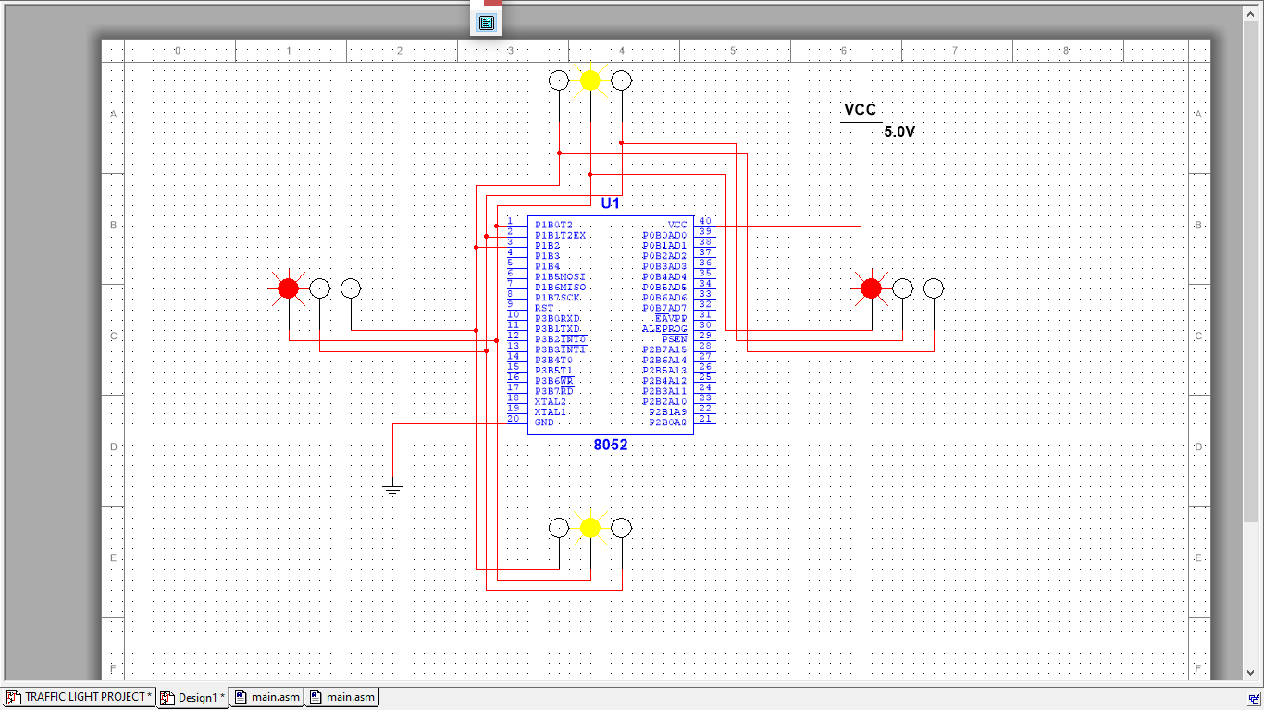

This traffic light control system works on the concept of fixed time allocation at each side of the junction which cannot be changed as per varying traffic density. Timings allotted at every junction are fixed. Sometimes higher traffic density at one side of the junction demands longer time duration for green signal compared to the standard allotted time.

Video Link: https://drive.google.com/file/d/1RhtgcTSnw5a7mTiVPd-vFro-LGV5DDGq/view?usp=sharing